GCS to BigQuery Pipeline Using Apache Airflow
Overview
This document describes the GCS to BigQuery pipeline using Apache Airflow for data orchestration. The final goal is to create a dashboard using the processed data in BigQuery.
Architecture Diagram
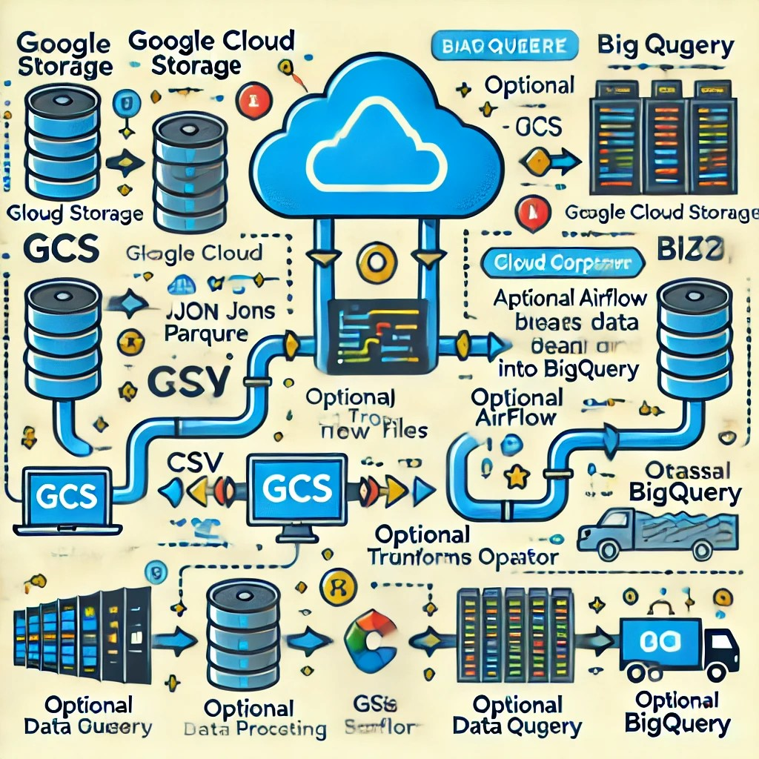

Key Components & Workflow
1. Google Cloud Storage (GCS) – Raw Data Storage
- Purpose: Acts as the landing zone for raw data before processing.
- Data Format: CSV, JSON, Parquet, or Avro files.
- Data Sources: External applications, IoT devices, APIs, or manual uploads.
- Trigger: A new file arrival in GCS initiates the pipeline.
2. Apache Airflow (Cloud Composer) – Pipeline Orchestration
- Purpose: Manages task execution, scheduling, and dependencies.
- Deployment: Can be self-managed (Apache Airflow on GKE/VM) or Cloud Composer (GCP managed Airflow).
Airflow DAG Tasks:
- GCS Sensor detects file arrival.
- Optional Dataflow job for preprocessing.
- GCSToBigQueryOperator loads data to the staging table.
- BigQueryExecuteQueryOperator transforms and merges data.
3. BigQuery – Data Warehousing & Analytics
- Purpose: Stores, processes, and analyzes large datasets efficiently.
- Table Structure:
  - Staging Table: Temporary storage for newly ingested raw data.
  - Final Table: Cleaned, transformed data ready for analysis.
- Optimization: Uses partitioning & clustering for performance.
4. BI Tool (Looker, Data Studio, Power BI) – Dashboarding
- Purpose: Visualizes processed data for insights & decision-making.
- Connection: Directly queries BigQuery for real-time analytics.
- Features:
  - Looker: Advanced analytics with LookML modeling.
  - Google Data Studio: Free tool for simple dashboards.
  - Power BI: Connects via BigQuery connector.

Data Flow Summary
- Data lands in GCS (raw format).
- Airflow detects new files and triggers DAG execution.
- Optional preprocessing via Dataflow (cleansing, transformation).
- Airflow loads data into BigQuery (staging → final table).
- BI tool fetches processed data for dashboarding.
Advantages of This Approach
- Scalable – Handles large data volumes efficiently.
- Cost-Effective – BigQuery charges only for queries, optimizing costs.
- Automated – Airflow schedules & monitors the entire workflow.
- Real-time Analysis – Dashboards update as new data arrives.

